To start/restart/stop a Subscription’s virtual machine(s):

Go to Home > Virtual Machines (or type Virtual Machines in the main search box) and click the Virtual Machines button.

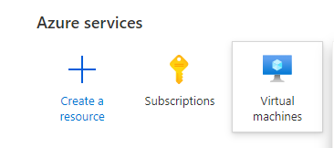

Click on the subscription filter and start typing in the name of the subscription until it shows up in the filtered list. Click on the subscription and then click on apply:

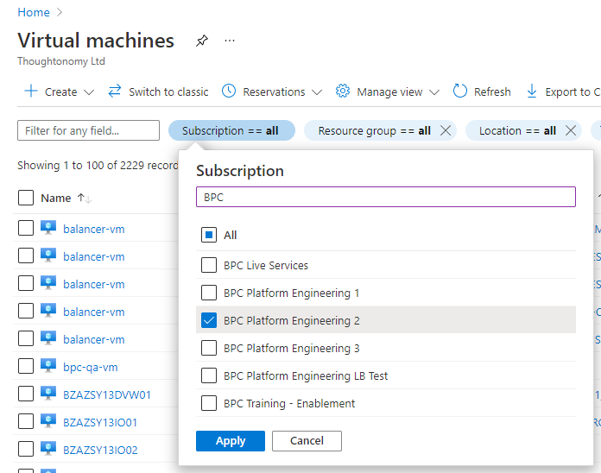

Now check the status column for “Stopped” > select the Virtual Machines you wish to start > click on the “Start” menu item. Note: this will take several minutes for the virtual machine to start. Click refresh every couple of minutes until all checked machines are started.

To Stop: Repeat the last step with the exception of now clicking the “Stop” item menu selection.